|  |
| --- |
| [ Roycol gs ] |
| Destroyer |
| **[Super hero of the space]** |
| Version 1.1  All work Copyright © 2015 by Roycol GS.  All rights reserved. |
| **[Roy Kim // 300818301]** |
|  |



|  |
| --- |
| July 10th 2015 |

**Table of Contents**

1. **Version History**
2. **Captured image**
3. **Game Information**

**I. Game Descriptions**

**II. Game Play Mechanics**

**III. Controls**

**IV. Interface sketch**

**V. Screen Descriptions**

**VI. Characters & Enemies**

**VI. Scoring**

**VII. Multimedia Index**

1. **Gitbub information**
2. **Version History**

|  |  |
| --- | --- |
| Version | Description |
| 1.0 | Initial draft of Destroyer |
| 2.0 | Inserting images and sounds |
| 3.0 | Change direction to horizontal and crash impact |
| 4.0 | Testing and Debugging part1 |
| 5.0 | Testing and Debugging part2 |
| 6.0 | Final commit |

1. **Captured image**

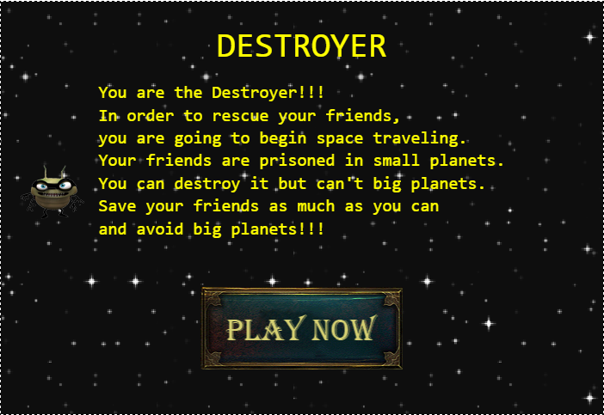

1. **Game Information**
2. **Game Description**

* *The game is to get high score on given lives. A user will get 5 lives at the beginning of game and it will be reduced every time when the user failed to avoid big planet’s rushing. The User can earn 100 points every time when the destroyer rescues a friend from small planet.*

1. **Game Play Mechanics**

* *The basic way that this game works is by using calculations of objects. For instance, if a planet is approaching to the destroyer, main collision process of this game will calculate distance between the two objects, and then change status of the destroyer and lives & score accordingly. Monitoring for the collision must take place immediately right after game begins. Of course, in case of a user’s game is over, it will offer another chance to play.*

1. **Controls**

* *Users can control movement of the Destroyer by using mouse. The Destroyer can be moved only vertically. Therefore, Users can scroll in either up and down direction to rescue friends or to avoid crashing planets.*

1. **Interface sketch**

|  |  |
| --- | --- |
|  | 1. **Instruction**  * **Title** * **Content(Instruction)** * **PlayButton** * **Instruction Screen** |
|  | 1. **Play**  * **Label for Lives** * **Label for Score** * **Game screen ( which are consist of Destroyer, Friends and Planets)** |
|  | 1. **Game Over**  * **Label for “GAME OVER”** * **Label for score** * **TryAgain Button (which will allow users to play the game again)** |

1. **Screen Descriptions**

|  |  |
| --- | --- |
|  | 1. **Lives :** number of life 2. **Score:** sum of points user earned. 3. **Destroyer:** main character which can be scrolled in either up and down direction. 4. **Friend:** friend who is imprisoned in a small planet. Users can rescue the friend by crashing. 5. **Planets:** obstacles that user should avoid 6. **Space:** background of the game |

1. **Characters & Enemies**

|  |  |
| --- | --- |
| **Division** | **Description** |
| **Destroyer** | **Main character of the game which will have an ugly face when it crashes a planet.** |
| **Friends** | **Friends of the Destroyer who is imprisoned in small planets.** |
| **Planets** | **Obstacles (Enemies). Each of them has different speed and direction.** |

1. **Multimedia Index**

|  |  |  |
| --- | --- | --- |
| **Division** | **Image** | **Description** |
| **Images** | **D:\college\semester4\Game Programming\assignment3\Destroyer\Destroyer\assets\images\destroyer.png** | **Destroyer (normal)** |
| **D:\college\semester4\Game Programming\assignment3\Destroyer\Destroyer\assets\images\destroyerCrash.png** | **Destroyer (crashed)** |
| **D:\college\semester4\Game Programming\assignment3\Destroyer\Destroyer\assets\images\friend.png** | **Friend** |
| **D:\college\semester4\Game Programming\assignment3\Destroyer\Destroyer\assets\images\planet.png** | **Planet** |
| **Sound** | **-** | **collision.wav** |
| **-** | **flight.wav** |
| **-** | **rescueFriend.wav** |

1. **Gitbub Information**

Url: <http://roycol.github.io/destroyer/Destroyer/>

Git Hub: <https://github.com/roycol/destroyer.git>